Project Requirements

Goals:

To build a balsa wood structure to hold a 200 g load 20 cm above the table top.

Rules:

The base of the crane must only contact the table within a 10 cm x 10 cm square

The bottom of the load must be supported 20 cm above the table top

The center of the load must be at least 5 cm horizontally outside the base of the crane

Materials and Supplies:

Two 0.125” x 0.125” x 36” pieces of balsa wood

One nail (to support the load)

One 500 g counterweight mass (cannot be a permanent part of your crane)

Balsa wood cutter or box cutter and a ruler

Glue, tape, string, etc to join your pieces of balsa wood together

Evaluation:

Submit a picture of your design, a very short description of how you built it, and a picture of your crane holding its final load.

If your crane could hold 300 g you can receive a maximum of 21 points

If your crane could only hold 200 g you can receive a maximum of 20 points

If your crane could only hold 100 g or less you can receive a maximum of 19 points

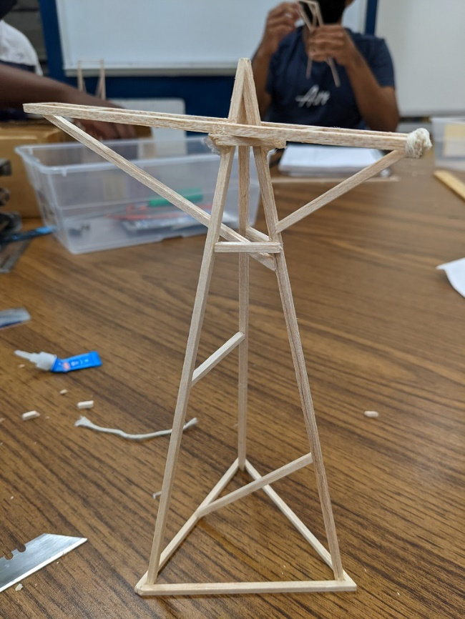Design Philosophy

When beginning my design, I was very aware of the amount of material I had to work with. At each point of design, I would measure how much material that would take and then make sure it was within the allotted budget of 182 cm. I also did not want to rely on string or even hot glue for my design, so I kept that in mind when designing. I did my design drawing in a 1:1 scale, which allowed for easily building.

Overview of my Design

For my design I went with a triangular base. I used the larges triangle I could, with 10 cm lengths of wood for the perimeter. I then added on a 3-sided pyramid that was 21.5 cm tall. The main arm of the crane only needed to be 20 cm off the ground, but this extra length allowed for a complete pyramid to be used and have the main arm rest of supports built onto that pyramid.

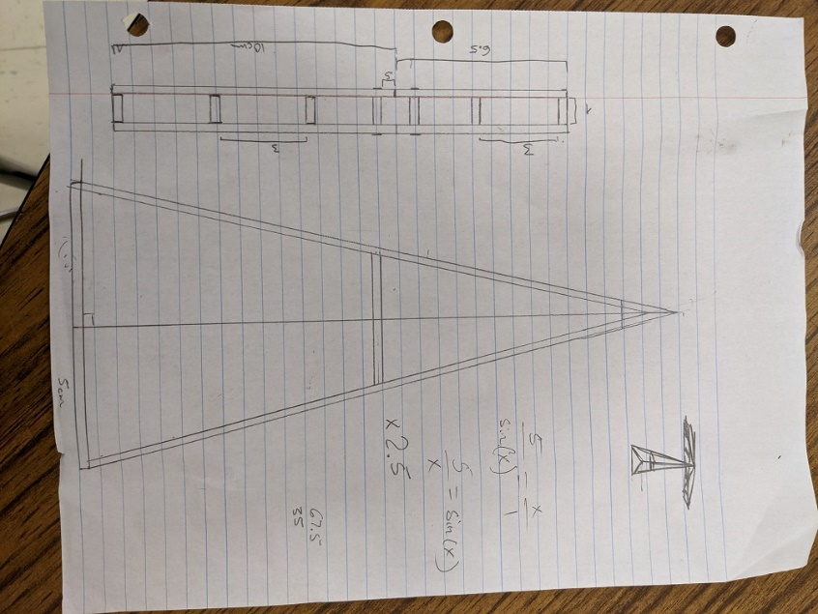 The arm was made to have the 500g weight and the 300g weight balanced correctly when the 300g weight was 10 cm away from the pyramid. This 10cm allowed me to have the 300g weight be 5cm out from the testing box. The 500g weight was only 6.5cm away from the pyramid base. I could have used the equation to calculate torque to figure out the spacing for the main arm, but I instead simulated the loads using a balance bar with the same weights used in the final test.

I did not draw out my design with the support that I knew I would need to fully support the weights. I did not know if I would want to have the main braces for the arm be tension or compression based. After building the tower and arm I decided to go with compression-based supports. Both sides of the arm were braced against the back tower length. This length was then connected to the two other lengths to help keep the tower from snapping. After this initial bracing I was left with enough balsa wood left over to brace the tower in a couple more locations. I chose to brace the back length again because of the amount of weight that would be on it. I then connect the remaining to lengths together to prevent them from bending and possibly snaping due to the weight.

For joining all the pieces together, I felt that using super glue was the only way to keep the design challenge an actual challenge. I did however end up using a small amount of hot glue at the main platform that held the arm onto the pyramid. This was done to quickly bond the platform to the 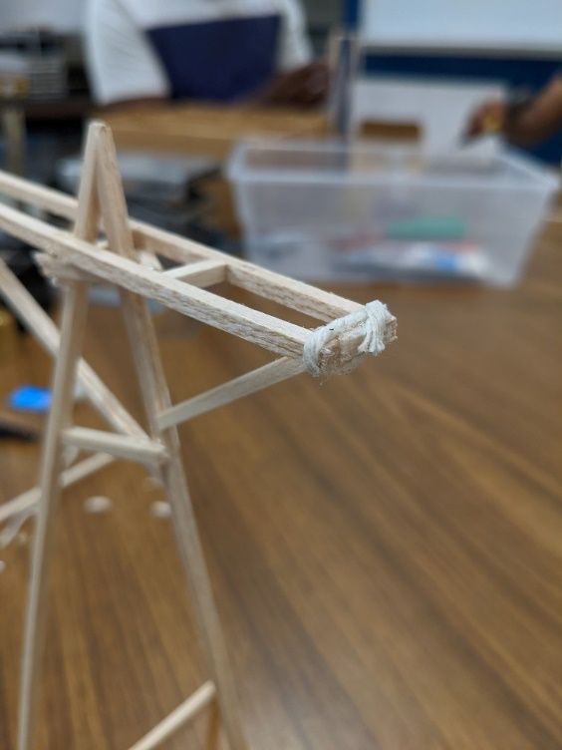pyramid, since otherwise I would have had to wait awhile for the superglue to dry in that area. I also did the same thing to one side of the arm. Instead of hot glue however I used a small length of string, his string was superglued on both ends and wrapped once around the back piece of balsa wood. This was done instead of superglue because the superglue joint was splitting due to the slight bend introduced by the triangle shape of the pyramid tip. I think that this part could have also been done with superglue, but it would have required the use of clamps, or a long amount of time spent with me holding it together.

Conclusion/Changes I would Make

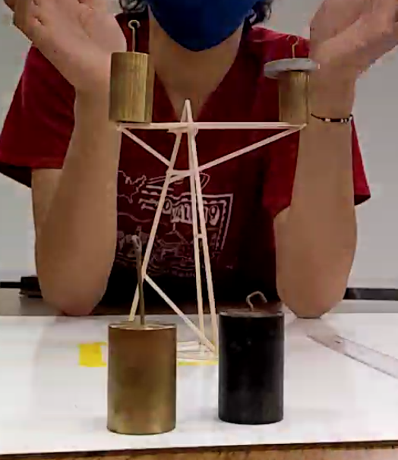 I think that this design worked amazingly well. I was very economical with my use of balsa wood, with only 3 centimeters worth being left over. As well I put trust into both the balsa wood and the superglue, and I was not disappointed. It held the 300g weight very easily. It was a little wobbly, but I was able to easily support the weight once it was placed carefully. If I had more wood, I would definitely add more bracing, but with the amount I was given I feel that I used the correct amount of wood I the right locations. If I had to do the project again, I think that I would bring superglue accelerant. That would have allowed me to build faster and with less mess.